Printer Name Assignments (PNA)

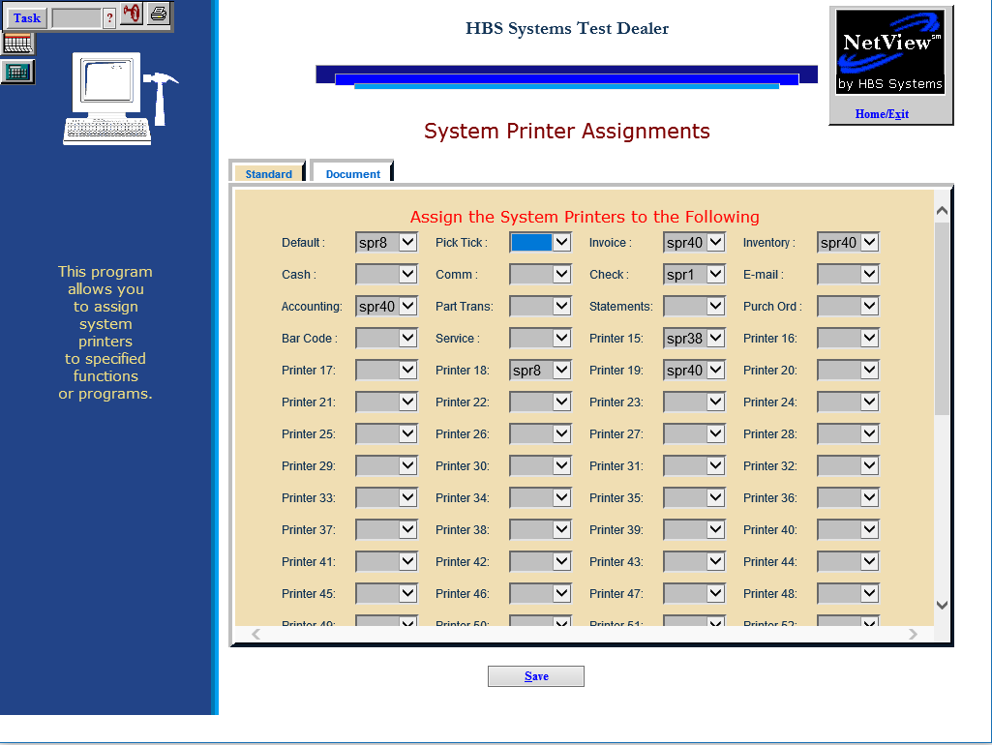

Printer Name Assignments (PNA) allows you to assign system printers to specific functions or programs. This is the program where you set your default printer for all applications.

To access this function, you can either:

* Select “System Maintenance” from the menu and choose the “Company File” submenu. Click “Printer Name Assignments.”
* Type “PNA” in the Shortcuts Bar

Standard Tab: Use this tab to assign .spr format printers to desired functions.

Default: Select a printer from this dropdown menu to set it as the default printer for all programs where a default printer is not otherwise selected.

Pick Tick: Select a printer from this dropdown menu to set it as the default picking ticket printer.

Invoice: Select a printer from this dropdown menu to set it as the default invoice printer

Inventory: Select a printer from this dropdown menu to set it as the default inventory printer.

Cash: Select a printer from this dropdown menu to set it as the default cash printer.

Comm: Select a printer from this dropdown menu to set it as the default Communications printer.

Check: Select a printer from this dropdown menu to set it as the default check printer.

E-mail: Select a printer from this dropdown menu to set it as the default e-mail printer.

Accounting: Select a printer from this dropdown menu to set it as the default accounting printer.

Part Trans: Select a printer from this dropdown menu to set it as the default parts transfer printer.

Statements: Select a printer from this dropdown menu to set it as the default statements printer.

Purch Ord: Select a printer from this dropdown menu to set it as the default purchase order printer.

Bar Code: Select a printer from this dropdown menu to set it as the default bar code printer.

Service: Select a printer from this dropdown menu to set it as the default Service printer.

Printer 15-99: The remaining fields let you assign names to any other printers you may have attached to the system.

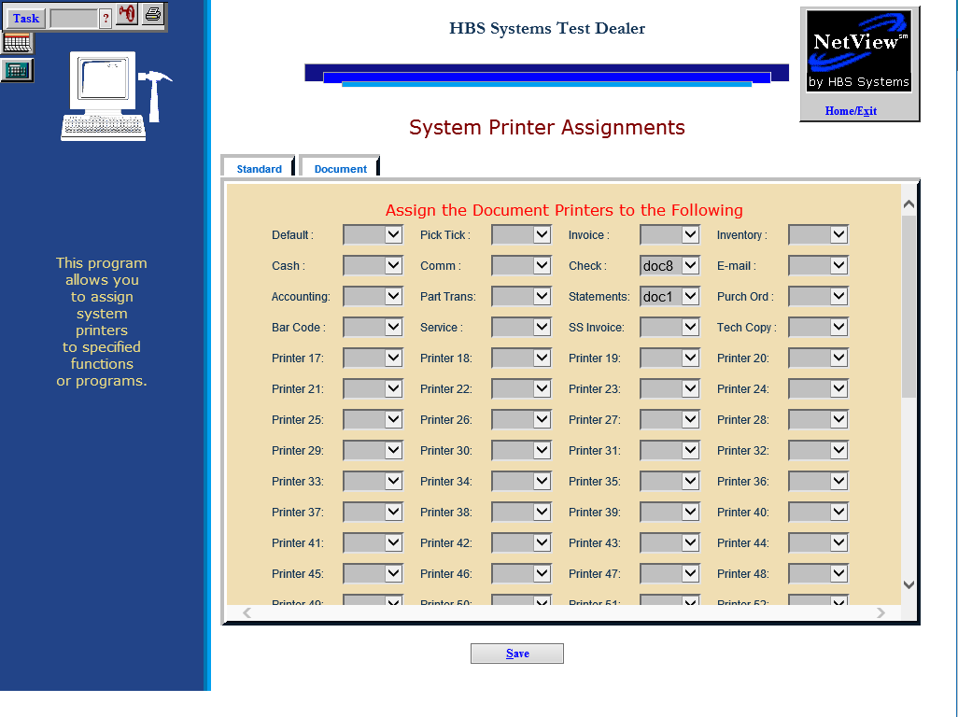

Document Tab: Use this tab to assign document printers to desired functions. The options will only consist of .doc format printers.

Default: Select a printer from this dropdown menu to set it as the default printer for all programs with a printing feature.

Pick Tick: Select a printer from this dropdown menu to set it as the default picking ticket printer.

Invoice: Select a printer from this dropdown menu to set it as the default invoice printer

Inventory: Select a printer from this dropdown menu to set it as the default inventory printer.

Cash: Select a printer from this dropdown menu to set it as the default cash printer.

Comm: Select a printer from this dropdown menu to set it as the default Communications printer.

Check: Select a printer from this dropdown menu to set it as the default check printer.

E-mail: Select a printer from this dropdown menu to set it as the default e-mail printer.

Accounting: Select a printer from this dropdown menu to set it as the default accounting printer.

Part Trans: Select a printer from this dropdown menu to set it as the default parts transfer printer.

Statements: Select a printer from this dropdown menu to set it as the default statements printer.

Purch Ord: Select a printer from this dropdown menu to set it as the default purchase order printer.

Bar Code: Select a printer from this dropdown menu to set it as the default bar code printer.

Service: Select a printer from this dropdown menu to set it as the default Service printer.

SS Invoice: Select a printer from this dropdown menu to set it as the default Service invoice printer.

Tech Copy: Select a printer from this dropdown menu to set it as the default Service printer for technician copies.

Printer 17-99: The remaining fields let you assign names to any other printers you may have attached to the system.